1. **KPI’s**
2. **Total Revenue**

select SUM(total_price) as Total_Revenue from pizza_sales

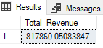

1. **Average Order Value**

select SUM(total_price)/ COUNT(distinct order_id) as Average_Total_Order from pizza_sales

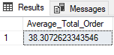

1. **Total Pizzas Sold**

select SUM(quantity) as Total_Pizza_Sold from pizza_sales

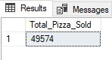

1. **Total Orders**

select count(distinct order_id) as Total_Orders from pizza_sales

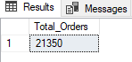

1. **Averages Pizza Per Order**

select cast(cast(sum(quantity) as decimal(10,2))/

cast(count(distinct order_id) as decimal(10,2)) as decimal(10,2))

as Avg_Pizzas_Per_Orders from pizza_sales

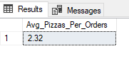

1. **Daily Trend for Total Orders:**

SELECT DATENAME(DW, order_date) AS Order_Day,COUNT(DISTINCT order_id) AS Total_Orders

FROM pizza_sales

GROUP BY DATENAME(DW, order_date), DATEPART(DW, order_date)

ORDER BY DATEPART(DW, order_date) ASC;

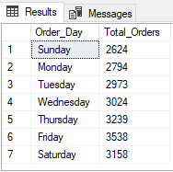

1. **Hourly Trend for Total Orders**

select DATEPART(HOUR,order_time) as Orders_Hours, COUNT(distinct order_id) as Total_Orders

from pizza_sales

group by DATEPART(Hour,order_time)

order by DATEPART(Hour,order_time)

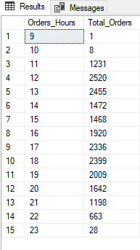

1. **Percentage of Sales by Pizza Category**

select pizza_category, SUM(total_price) as Total_Sales, sum(total_price)*100/

(select SUM(total_price) from pizza_sales) as Percentage_Sales_Categorywise

from pizza_sales

group by pizza_category

order by Percentage_Sales_Categorywise asc

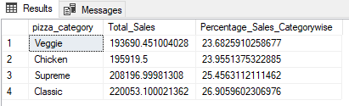

1. **Percentage of Sales by Pizza Size**

select pizza_size, round(SUM(total_price),2) as Total_Sales, round(sum(total_price)*100/

(select SUM(total_price) from pizza_sales),2) as Percentage_Sales_Categorywise

from pizza_sales

group by pizza_size

order by Percentage_Sales_Categorywise asc

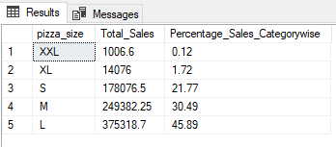

1. **Total Pizzas sold by Pizza Category**

select pizza_category, SUM(quantity) as Total_Sold

from pizza_sales

group by pizza_category

order by Total_Sold

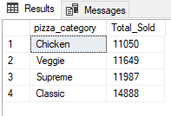

1. **Top 5 Best Sellers by Total Pizzas Sold**

select top 5 pizza_name, SUM(quantity) as Total_Pizza_Sold

from pizza_sales

group by pizza_name

order by Total_Pizza_Sold desc

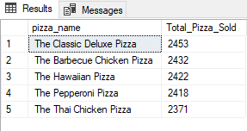

1. **Bottom 5 Worst Sellers by Total Pizzas Sold**

select top 5 pizza_name, SUM(quantity) as Total_Pizza_Sold

from pizza_sales

group by pizza_name

order by Total_Pizza_Sold

